PCG-RA V1
PCG-RA (Procedural Content Generation Reference Architecture)
(Reading time: 30 minutes)

Introduction 1
Goals 2
Stakeholders 2
Functional Requirements and Quality Metrics 3
Architectural visions 5
Conceptual Vision 6
Functional Vision 8
Structural Vision 9
Structural View (Map Generator Example) 10
Procedural View (PCGManager and Generator) 11
Procedural View (Generator) 12
Procedural View (GameManager) 12
Procedural View (LevelEditor) 13
Risks 13

Introduction
Reference architectures are a type of software architecture that seeks to provide guidance for the development, standardization, and evolution of system architectures within a defined domain.

This document aims to specify the design of the reference architecture known as PCGRA (Procedural Content Generation Reference Architecture). The proposed architecture seeks to establish a standard for games that use procedural content generation, allowing games to adapt, validate, and orchestrate various types of content, with a high level of control over the generation process.

The architecture was developed with a focus on orchestrating maps and quests. However, it can also be used to integrate other types of content according to the game's requirements. There are also mechanisms that allow the generation system to be informed of player and game data to enable adapted content generation. Furthermore, the architecture also allows for joint content validation to establish a minimum level of feasibility for the generated content.

Accompanied by this material, a video was created to accompany the sectionArchitectural visions, available (in Portugêse) at apresentacao-pcgra.mkv.

The following sections will present the objectives, requirements, attributes, risks, stakeholders, and perspectives of the architecture, in order to enable its implementation.

Goals
The PCG-RA architecture has the following defined objectives:
- Generating arbitrary-sized content in game time:
Games often require continuous content generation. One example is Minecraft, which uses procedural generation to create an "infinite" world. For these types of games, the architecture must allow for new content to be generated as needed and must also be performant so that the generation process can be executed in-game.

- Allow new generation algorithms to be coupled, replaced or modified, in order to allow games that rely heavily on content generation the freedom to explore new generation algorithms in a modular way.

- Adapting content to players. In this sense, content generation can be leveraged to generate content tailored to the player experience. The architecture should allow player information to aid in content generation.

- Content generation is strongly influenced by the designer's decisions: The generation system must allow itself to be influenced by changing the metrics used for generation, as well as being used in conjunction with manually created content introduced by the designer.

Stakeholders
- Players: These are the primary users who will experience the game's content. They can be the system's end user, a tester, or the designer themselves, who test the content before making it available to end users.
- Designers: Responsible for guiding the content creation process, being able to change the parameters used to generate the game and also being able to introduce manual content into the generation process.
- Developers: Mainly responsible for maintaining the system. They work alongside the designers to implement the generation algorithms.

Functional Requirements and Quality Metrics
Quality metrics are essential for defining the architectural requirements that serve as the basis for architecture creation. Quality metrics define the characteristics that the architecture should strive to meet.

DSeveral academic studies were analyzed to define the requirements of architecture on architecture in the context of procedural content generation. A total of nine studies were analyzed, and the main quality metrics were extracted from them:

Quality metrics
Modularity | The extent to which the system can be divided into smaller parts is directly influenced by the architectural coupling and cohesion.
Extensibility | How much the system can be extended to add new generators.
Modifiability | The ease of the system being modified.
Maintainability | How maintainable the system can be over time.
Portability | The ease of porting the system to different environments, including games already in development and game engines.
Scalability | The system's ease in increasing its content generation capacity.
Performance | How fast the system is at generating content.
Usability | How suitable the system is for use by the designer to generate content.
Comprehensiveness | The ease with which the system can be understood by the user.
Controllability | How much the system allows the user to have control over the content generation processes.
Feasibility | How suitable the generated content is for the game.
Adaptability | How much the generated content is tailored to a specific player.
Variability | How varied the content generated is.

Based on the quality metrics and requirements extracted from the studies, the proposed architecture aims to meet the following architectural requirements:

Requirement | Justification
Adapt content | In order to allow the generation of content appropriate to the game's narratives and different players.
Collect player data | In order to adapt the generated content, it is necessary to gather information from players, either during the game or through questionnaires.
Collect game data | In order to adapt the content as the game progresses.
Validate/Test content | To allow content to be validated before being returned to users. This can be done to ensure a certain level of feasibility or variability in the content.
Add or modify generator modules | In order to allow the addition of new generators in a modular manner, w
Modify module parameters | In order to allow the generation of content of arbitrary sizes, in a coherent manner and at different levels of granularity, in addition to allowing a greater level of controllability by the designer.
Orchestrate content | For games that require the generation of more than one type of content in a combined way.
Generate on-demand content in real time | Many games want to generate content on demand while the game is running.
Allow parallel generation | One way to enable scalable content generation at the architectural level is to allow content to be generated in parallel.
Cache of generated content | Performance can be improved by using a generation cache, so that content is not generated redundantly.
Change content manually | In order to allow the designer to adjust the levels upon their view.
Show generation information | In order to provide feedback on the effects of designers' decisions on the generation process.
Generic interface for the generation system | A generic interface should allow the system to be used in a more accessible way, without transferring internal complexity to the user. Furthermore, it should allow the system to be ported more easily to other platforms.

With these requirements considered, the next section will present the architectural views that represent the architecture.

Architectural visions
The following sections presented the architecture mediated by different points of view:
- Conceptual: presents a high-level view of the system. For this, the block diagrams of theSysML, which allow you to describe the attributes present in each module and their relationship with the other modules
- Functional: presents the system from the point of view of which functionalities are offered to each stakeholder;
- Structural: presents the code structure in terms of classes and modules;
- Procedural: presents the form of the architecture in terms of concurrent units. It can describe different processes, threads, programs, or modules executing concurrently;

The diagrams were created using the tooldiagrams.net, following the modeling standardsSysML (System Modeling Language).

Additionally, a video was created to explain the structural view and the example of the map generator in a didactic way. Available atapresentacao-pcgra.mkv.

For a better understanding of the architecture, it is recommended to start reading with the conceptual view for a general overview, followed by watching the video, which shows the functionality of the architecture in a didactic way.

Conceptual Vision
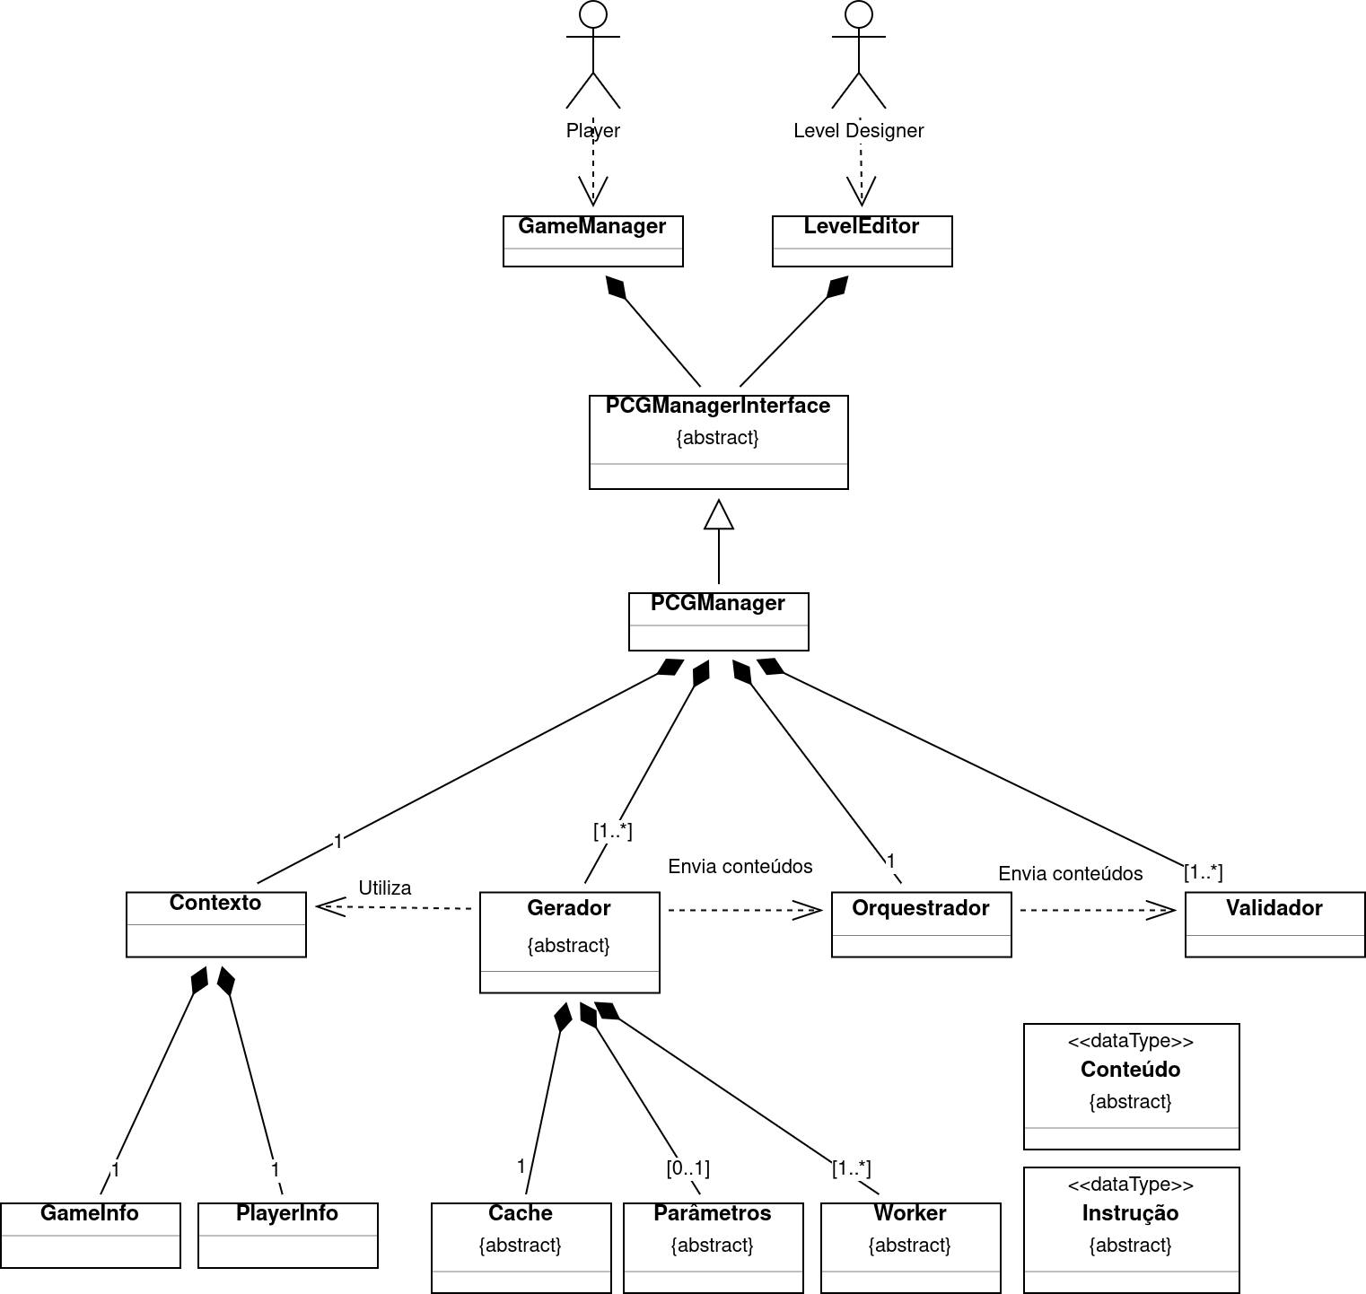
Of which:
- Contentis the type of data that will be generated. It can be an enemy, a map, a song, etc.
- GameManagerImplements game logic and presents generated content to the player, requests the generation of new content if desired, and acquires information from the player if the content is to be adapted;
- LevelEditorallows the designer to interact directly with PCGManager, the designer can send generation instructions and change parameters and context directly;
- Instructionis the data type used to request the generation of specific content. It should be used according to the content to be generated. In a map generation example, the instruction might indicate the quadrant to be generated.
- ContentManagerInterface a interface com o do PCGManagerwith the game or tool. Allows you to enter generation context data, generation parameters, and request and receive content;
- PCGManagerImplements the interface. Controls the entire content creation process and implements the interface that interacts with clients who make content available to designers and players;
  - ContextIt adds contextual information that can be used to assist in the generation process, in order to adapt the content to the players or to the specific themes of the game;
    - GameInfois the type of data that aggregates game information: difficulty level, progress level
    - PlayerInfois the ttype of data that aggregates player information: profile, survey responses
  - Generatorcontrols the process of generating specific content:
    - Parametersthat are used in generation, for example, in a map generator the parameters can be the type of terrain to be generated, the maximum and minimum height of the terrain;
    - Cacheused to store content already generated, in order to not generate redundant content;
    - Workerandexecutes a generation instruction, it can be instantiated multiple times to perform multiple instructions in parallel, in which each worker will be inherent to a thread.
- Orchestratoris responsible for joiningall content in a single artifact. It offers methods for adding content individually, and a method for combining all previously added content;
- ValidatorValidates the feasibility of the generated artifact. Internally, validation can be performed using algorithms or intelligent agents. It allows the use of a feasibility threshold, which determines whether the content is suitable or not;

Functional Vision
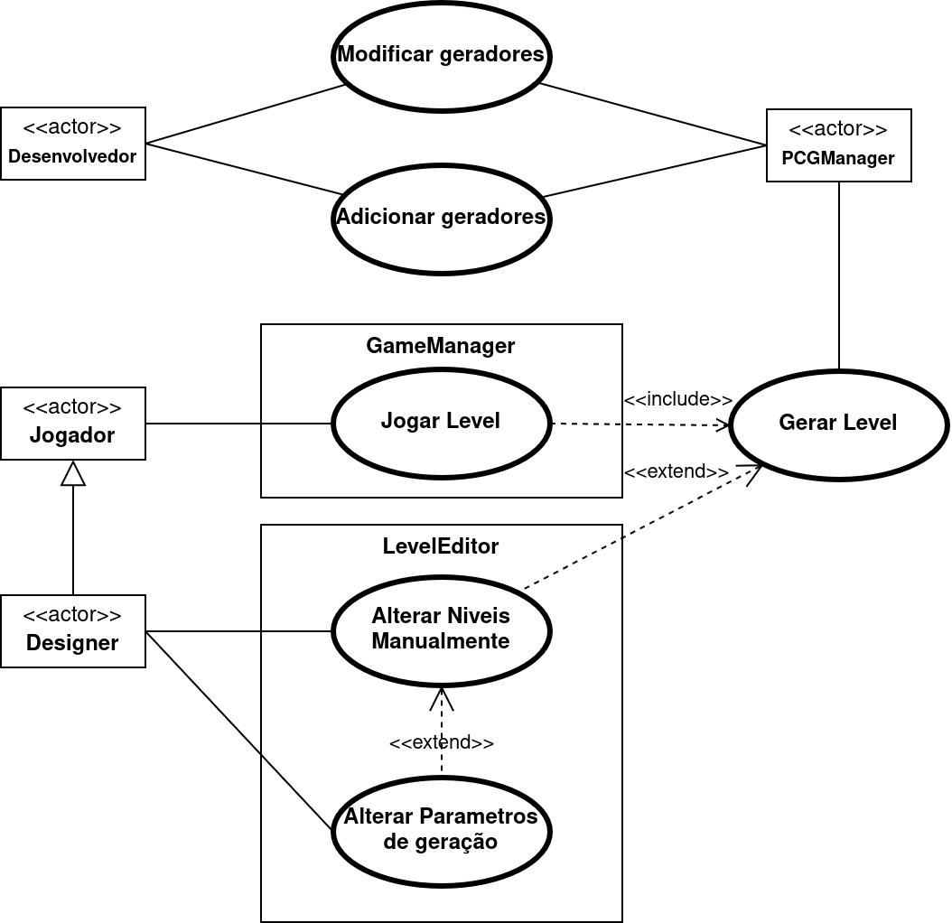
Initially, developers will be responsible for modifying and adding generators. Designers can manually modify levels and adjust generation parameters. Players, the end users, can play the levels, whether or not they were generated with the designer's help.

Structural Vision
Part 1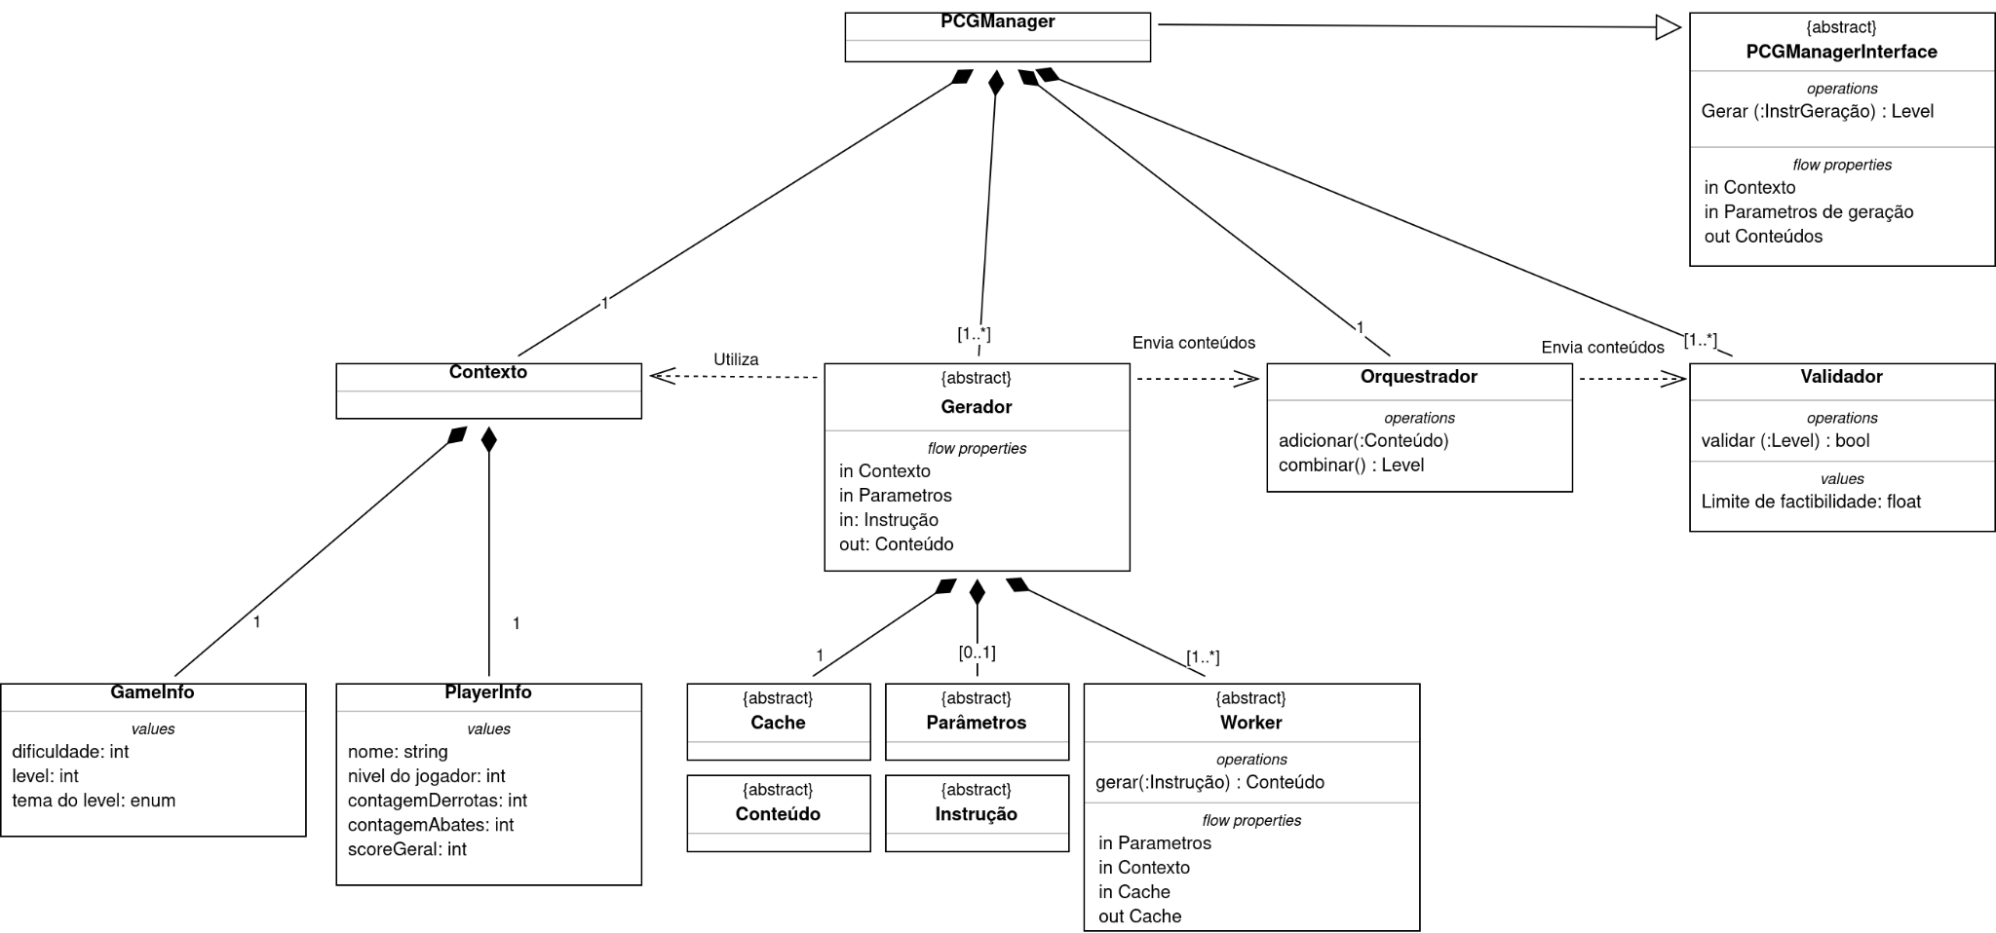Part 2
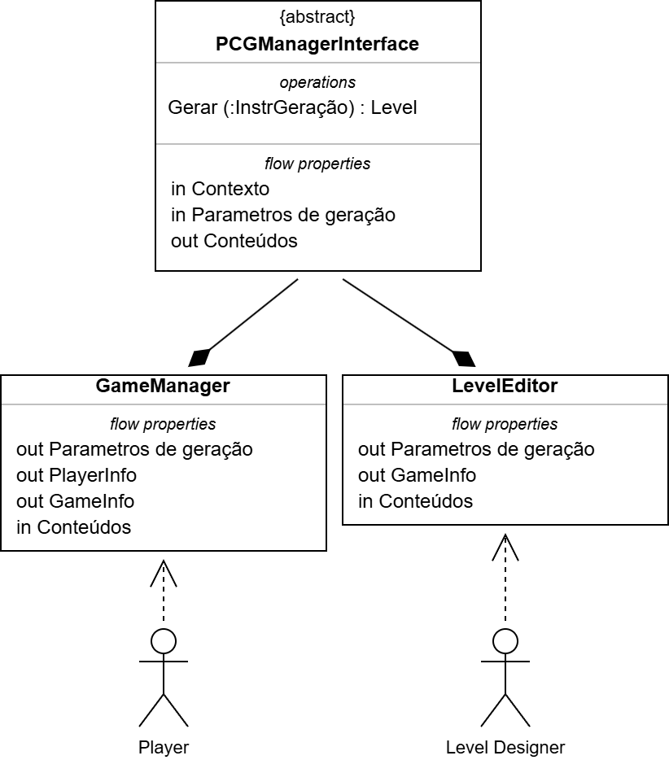
The system's operation can be seen above. For example, the GameInfo and PlayerInfo components have attributes such as difficulty level, level, level theme, and the player's name, defects, kills, and score.
The ComponentGeneratorcontinuously receives context data, parameters and generation instructions and uses this information to generate content from theWorker.
As the contents are generated they are added to the orchestrator, which will combine them and add them to theValidator.The validator's role is to evaluate the content and generate a score. This score will be compared to the feasibility threshold, which, if not exceeded, will restart the generation process.
TheGameManagerand LeveEditorinteract with the interface ofPCGManagercontinually adding information fromplayerand instructions of thedesigner. In this way, they serve as a means of making the content generated by PCGManager available.LevelEditorhas a more direct interaction with thedesigner, as it allows you more direct control over the generation process. TheGameManageron the other hand, it must present the game's logic, so the player interacts indirectly with the generation system, mediated by the gameplay.
The next structural view presents an example of how a map generator could be implemented using this architecture.

Structural View (Map Generator Example)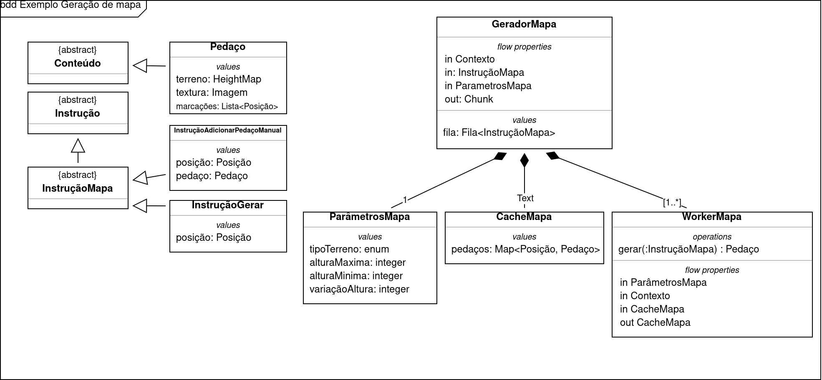
The example above presents a way to implement a map generator capable of generating the map modularly, with each "piece" of the map generated individually. The components are:
- Chunk is the abstracted data type of the typeContent, swill be the final product of a generation iteration. It consists of a height map (HeightMap) that represents the topology of the generated position, texture and markings, which are interesting points to place enemies, treasures, etc.
- GenerateInstructionis an instruction to generate a specific map position;
- InstructionAddPieceManualis an instruction used by the designer to change a part of the map manually, which allows him to make small adjustments, or even add content manually, such as specific buildings in the game, for example.
- Map Parametersare the set of parameters used for generation. As the example shows, it consists of the following attributes:
  - tipoTerreno: displays the type of terrain to be generated. For example, the types could be: "forest", "mountainous", "stream", "glacial", etc.;
  - maximumheightandMinimumHeight: influence on the limits of the topology that will be generated;
  - Height variation: changes the uniformity of the generated topology. The higher the uniformity, the greater the difference in height between one point and another.
- CacheMapa: stores the pieces already created, if the same instruction is requested again, the cache is used to return the stored piece;
- WorkerMapa: implements the map generation methods, which use the set ofcontext, parametersMapandGenerate instructionto generate aChunkof the map. Note that thecontextandparametersMapare added before generation occurs, the generation process only happens after the method is calledto generate. It can be instantiated multiple times in order to perform generation in parallel.

Procedural View (PCGManager and Generator)
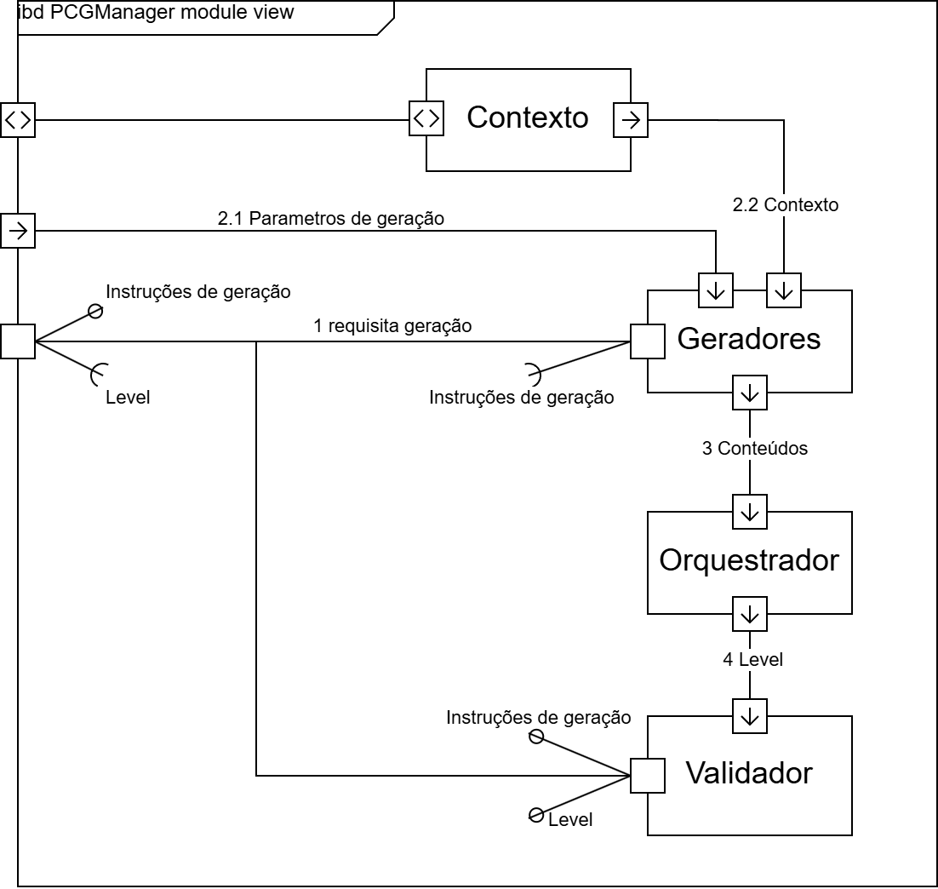
The generation process begins when the generators receive a generation instruction. The generators then use context data and previously received parameters to assist in the generation process. After generation, the contents are passed to theOrchestratorand then to theValidator. TheValidatorvalidates the generated level and can request a new generation, or return the content to the client.

Procedural View (Generator)
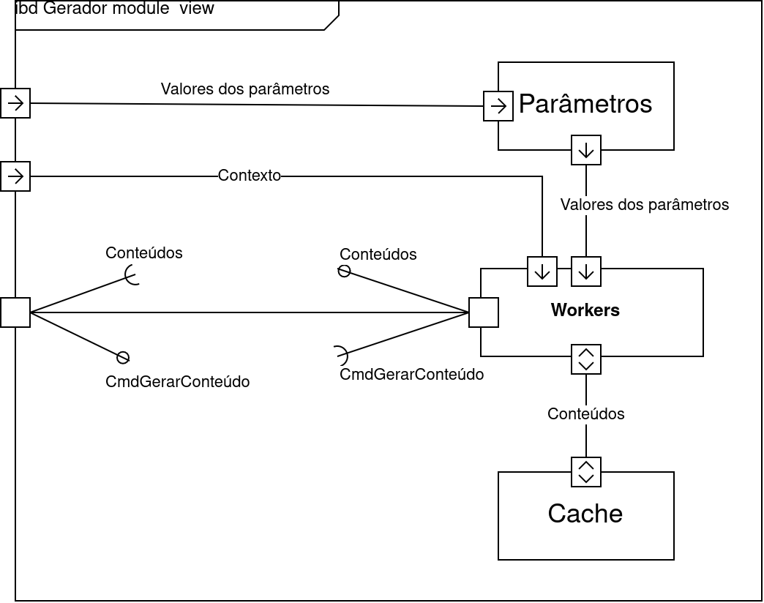
Inside the generator, it is made up of theParameters, Workers andCache. The generation process is performed when theWorkerreceives the command to generate the content, when it queries theParameters, Contextand Cacheto perform the generation.

Procedural View (GameManager)
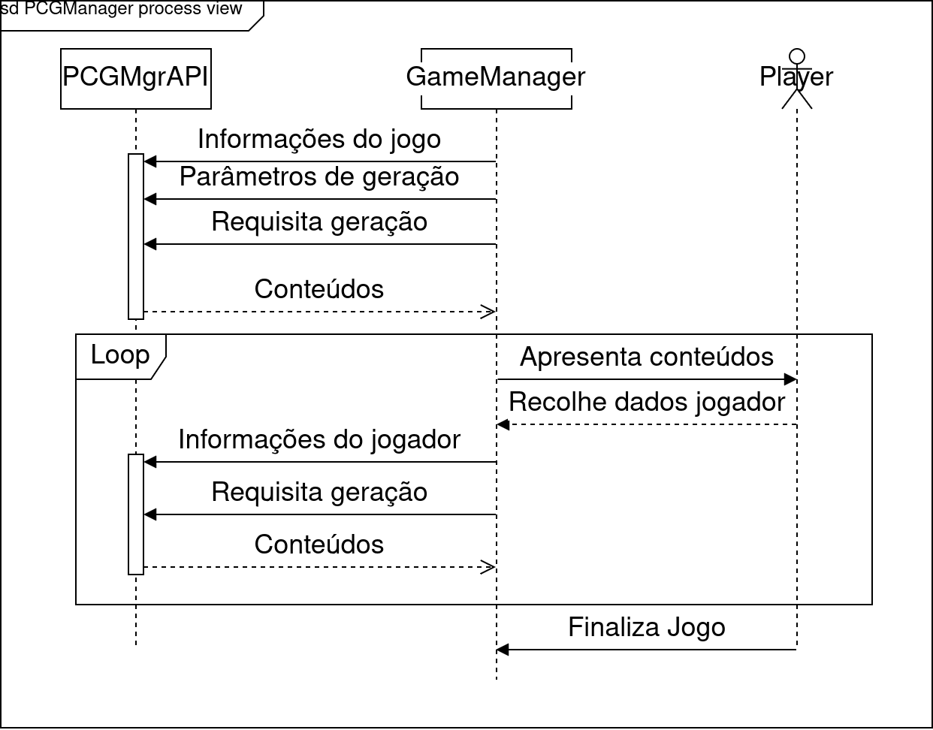
The interaction between the player and thePCGManager. Game information and generation parameters are provided byGameManager for the PCGManagerBefore the game begins, the first interaction with the player is receiving content. Content is presented interactively to the player, and while the player enjoys the game, information is acquired and used to generate subsequent content.

Procedural View (LevelEditor)
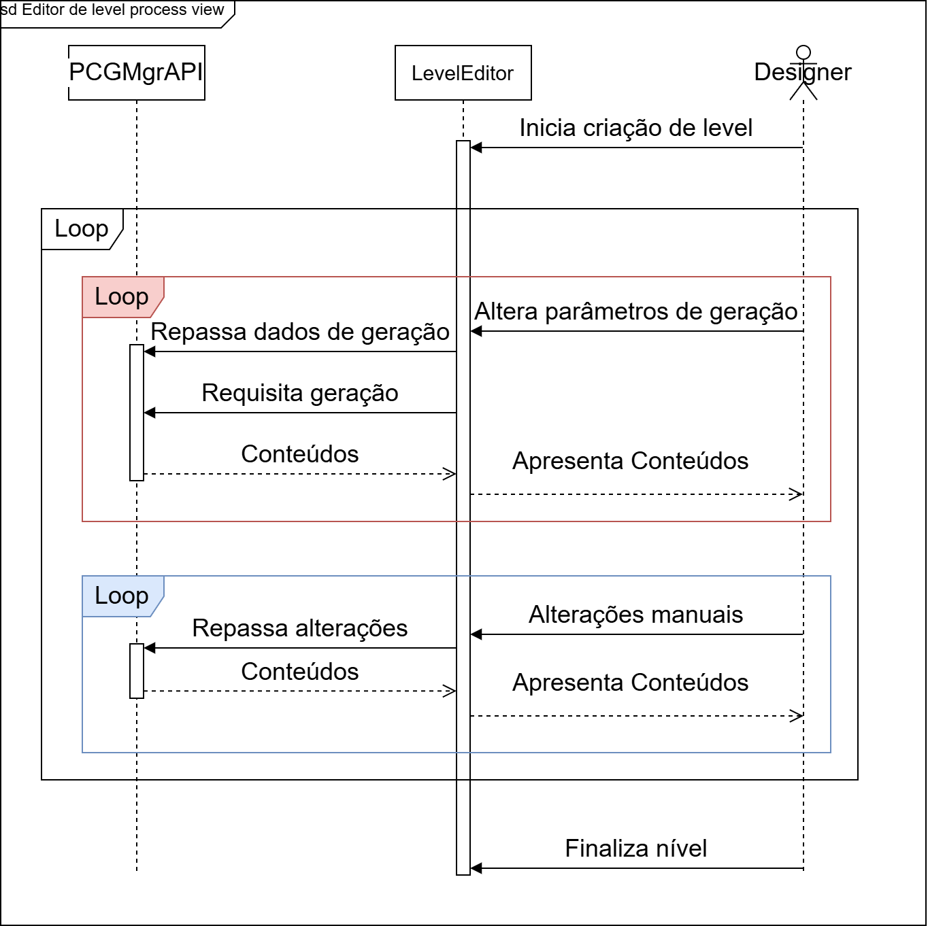

Unlike theGameManager, in the level creation process the designer has much greater control over the generation processes. The designer has two main interactions with thePCGManager(mediated byLevelEditor): (1) Change the generation parameters and (2) change the contents manually.

Risks
Some risks in using thePCGRA:
- Architectural degradation, when the quality of the architecture deteriorates over time;
- The architecture may not cover the entire scope of generation if a desired generation technique cannot be implemented within it;
- The validation module may be unnecessary if no validation technique is applied;
- Often, multiple pieces of content are generated together, in which case the content orchestration component becomes irrelevant. Since the content is already created jointly;

PCG-RA V2
PCG-RA (Procedural Content Generation Reference Architecture)
(Reading time: 30 minutes)

Introduction 1
Goals 2
Stakeholders 2
Functional Requirements and Quality Metrics 3
Architectural visions 5
Conceptual Vision 6
Functional Vision 8
Structural Vision 9
Structural View (Map Generator Example) 10
Procedural View (PCGManager and Generator) 11
Procedural View (Generator) 12
Procedural View (GameManager) 12
Procedural View (LevelEditor) 13
Risks 13

Introduction
Reference architectures are a type of software architecture that seeks to provide guidance for the development, standardization, and evolution of system architectures within a defined domain.

This document aims to specify the design of the reference architecture known as PCGRA (Procedural Content Generation Reference Architecture). The proposed architecture seeks to establish a standard for games that use procedural content generation, allowing games to adapt, validate, and orchestrate various types of content, with a high level of control over the generation process.

The architecture was developed with a focus on orchestrating maps and quests. However, it can also be used to integrate other types of content according to the game's requirements. There are also mechanisms that allow the generation system to be informed of player and game data to enable adapted content generation. Furthermore, the architecture also allows for joint content validation to establish a minimum level of feasibility for the generated content.

Accompanied by this material, a video was created to accompany the section Architectural visions, available (in Portugêse) at apresentacao-pcgra.mkv.

The following sections will present the objectives, requirements, attributes, risks, stakeholders, and perspectives of the architecture, in order to enable its implementation.

Goals
The PCG-RA architecture has the following defined objectives:
- Generating arbitrary-sized content in game time:
Games often require continuous content generation. One example is Minecraft, which uses procedural generation to create an "infinite" world. For these types of games, the architecture must allow for new content to be generated as needed and must also be performant so that the generation process can be executed in-game.

- Allow new generation algorithms to be coupled, replaced or modified, in order to allow games that rely heavily on content generation the freedom to explore new generation algorithms in a modular way.

- Adapting content to players. In this sense, content generation can be leveraged to generate content tailored to the player experience. The architecture should allow player information to aid in content generation.

- Content generation is strongly influenced by the designer's decisions: The generation system must allow itself to be influenced by changing the metrics used for generation, as well as being used in conjunction with manually created content introduced by the designer.

Stakeholders
- Players: These are the primary users who will experience the game's content. They can be the system's end user, a tester, or the designer themselves, who test the content before making it available to end users.
- Designers: Responsible for guiding the content creation process, being able to change the parameters used to generate the game and also being able to introduce manual content into the generation process.
- Developers: Mainly responsible for maintaining the system. They work alongside the designers to implement the generation algorithms.

Functional Requirements and Quality Metrics
Quality metrics are essential for defining the architectural requirements that serve as the basis for architecture creation. Quality metrics define the characteristics that the architecture should strive to meet.

DSeveral academic studies were analyzed to define the requirements of architecture on architecture in the context of procedural content generation. A total of nine studies were analyzed, and the main quality metrics were extracted from them:

Quality metrics
Modularity | The extent to which the system can be divided into smaller parts is directly influenced by the architectural coupling and cohesion.
Extensibility | How much the system can be extended to add new generators.
Modifiability | The ease of the system being modified.
Maintainability | How maintainable the system can be over time.
Portability | The ease of porting the system to different environments, including games already in development and game engines.
Scalability | The system's ease in increasing its content generation capacity.
Performance | How fast the system is at generating content.
Usability | How suitable the system is for use by the designer to generate content.
Comprehensiveness | The ease with which the system can be understood by the user.
Controllability | How much the system allows the user to have control over the content generation processes.
Feasibility | How suitable the generated content is for the game.
Adaptability | How much the generated content is tailored to a specific player.
Variability | How varied the content generated is.

Based on the quality metrics and requirements extracted from the studies, the proposed architecture aims to meet the following architectural requirements:

Requirement | Justification
Adapt content | In order to allow the generation of content appropriate to the game's narratives and different players.
Collect player data | In order to adapt the generated content, it is necessary to gather information from players, either during the game or through questionnaires.
Collect game data | In order to adapt the content as the game progresses.
Validate/Test content | To allow content to be validated before being returned to users. This can be done to ensure a certain level of feasibility or variability in the content.
Add or modify generator modules | In order to allow the addition of new generators in a modular manner, w
Modify module parameters | In order to allow the generation of content of arbitrary sizes, in a coherent manner and at different levels of granularity, in addition to allowing a greater level of controllability by the designer.
Orchestrate content | For games that require the generation of more than one type of content in a combined way.
Generate on-demand content in real time | Many games want to generate content on demand while the game is running.
Allow parallel generation | One way to enable scalable content generation at the architectural level is to allow content to be generated in parallel.
Cache of generated content | Performance can be improved by using a generation cache, so that content is not generated redundantly.
Change content manually | In order to allow the designer to adjust the levels upon their view.
Show generation information | In order to provide feedback on the effects of designers' decisions on the generation process.
Generic interface for the generation system | A generic interface should allow the system to be used in a more accessible way, without transferring internal complexity to the user. Furthermore, it should allow the system to be ported more easily to other platforms.

With these requirements considered, the next section will present the architectural views that represent the architecture.

Architectural visions
The following sections presented the architecture mediated by different points of view:
- Conceptual: presents a high-level view of the system. For this, the block diagrams of theSysML, which allow you to describe the attributes present in each module and their relationship with the other modules
- Functional: presents the system from the point of view of which functionalities are offered to each stakeholder;
- Structural: presents the code structure in terms of classes and modules;
- Procedural: presents the form of the architecture in terms of concurrent units. It can describe different processes, threads, programs, or modules executing concurrently;

The diagrams were created using the tooldiagrams.net, following the modeling standardsSysML (System Modeling Language).

Additionally, a video was created to explain the structural view and the example of the map generator in a didactic way. Available atapresentacao-pcgra.mkv.

For a better understanding of the architecture, it is recommended to start reading with the conceptual view for a general overview, followed by watching the video, which shows the functionality of the architecture in a didactic way.

Conceptual Vision
Of which:
- Contentis the type of data that will be generated. It can be an enemy, a map, a song, etc.
- GameManagerImplements game logic and presents generated content to the player, requests the generation of new content if desired, and acquires information from the player if the content is to be adapted;
- LevelEditorallows the designer to interact directly with PCGManager, the designer can send generation instructions and change parameters and context directly;
- Instructionis the data type used to request the generation of specific content. It should be used according to the content to be generated. In a map generation example, the instruction might indicate the quadrant to be generated.
- ContentManagerInterface a interface com o do PCGManagerwith the game or tool. Allows you to enter generation context data, generation parameters, and request and receive content;
- PCGManagerImplements the interface. Controls the entire content creation process and implements the interface that interacts with clients who make content available to designers and players;
  - ContextIt adds contextual information that can be used to assist in the generation process, in order to adapt the content to the players or to the specific themes of the game;
    - GameInfois the type of data that aggregates game information: difficulty level, progress level
    - PlayerInfois the ttype of data that aggregates player information: profile, survey responses
  - Generatorcontrols the process of generating specific content:
    - Parametersthat are used in generation, for example, in a map generator the parameters can be the type of terrain to be generated, the maximum and minimum height of the terrain;
    - Cacheused to store content already generated, in order to not generate redundant content;
    - Workerandexecutes a generation instruction, it can be instantiated multiple times to perform multiple instructions in parallel, in which each worker will be inherent to a thread.
- Orchestratoris responsible for joiningall content in a single artifact. It offers methods for adding content individually, and a method for combining all previously added content;
- ValidatorValidates the feasibility of the generated artifact. Internally, validation can be performed using algorithms or intelligent agents. It allows the use of a feasibility threshold, which determines whether the content is suitable or not;

Functional Vision
Initially, developers will be responsible for modifying and adding generators. Designers can manually modify levels and adjust generation parameters. Players, the end users, can play the levels, whether or not they were generated with the designer's help.

Structural Vision
Part 1Part 2
The system's operation can be seen above. For example, the GameInfo and PlayerInfo components have attributes such as difficulty level, level, level theme, and the player's name, defects, kills, and score.
The ComponentGeneratorcontinuously receives context data, parameters and generation instructions and uses this information to generate content from theWorker.
As the contents are generated they are added to the orchestrator, which will combine them and add them to theValidator.The validator's role is to evaluate the content and generate a score. This score will be compared to the feasibility threshold, which, if not exceeded, will restart the generation process.
TheGameManagerand LeveEditorinteract with the interface ofPCGManagercontinually adding information fromplayerand instructions of thedesigner. In this way, they serve as a means of making the content generated by PCGManager available.LevelEditorhas a more direct interaction with thedesigner, as it allows you more direct control over the generation process. TheGameManageron the other hand, it must present the game's logic, so the player interacts indirectly with the generation system, mediated by the gameplay.
The next structural view presents an example of how a map generator could be implemented using this architecture.

Structural View (Map Generator Example)
The example above presents a way to implement a map generator capable of generating the map modularly, with each "piece" of the map generated individually. The components are:
- Chunk is the abstracted data type of the typeContent, swill be the final product of a generation iteration. It consists of a height map (HeightMap) that represents the topology of the generated position, texture and markings, which are interesting points to place enemies, treasures, etc.
- GenerateInstructionis an instruction to generate a specific map position;
- InstructionAddPieceManualis an instruction used by the designer to change a part of the map manually, which allows him to make small adjustments, or even add content manually, such as specific buildings in the game, for example.
- Map Parametersare the set of parameters used for generation. As the example shows, it consists of the following attributes:
  - tipoTerreno: displays the type of terrain to be generated. For example, the types could be: "forest", "mountainous", "stream", "glacial", etc.;
  - maximumheightandMinimumHeight: influence on the limits of the topology that will be generated;
  - Height variation: changes the uniformity of the generated topology. The higher the uniformity, the greater the difference in height between one point and another.
- CacheMapa: stores the pieces already created, if the same instruction is requested again, the cache is used to return the stored piece;
- WorkerMapa: implements the map generation methods, which use the set ofcontext, parametersMapandGenerate instructionto generate aChunkof the map. Note that thecontextandparametersMapare added before generation occurs, the generation process only happens after the method is calledto generate. It can be instantiated multiple times in order to perform generation in parallel.

Procedural View (PCGManager and Generator)
The generation process begins when the generators receive a generation instruction. The generators then use context data and previously received parameters to assist in the generation process. After generation, the contents are passed to theOrchestratorand then to theValidator. TheValidatorvalidates the generated level and can request a new generation, or return the content to the client.

Procedural View (Generator)
Inside the generator, it is made up of theParameters, Workers andCache. The generation process is performed when theWorkerreceives the command to generate the content, when it queries theParameters, Contextand Cacheto perform the generation.

Procedural View (GameManager)
The interaction between the player and thePCGManager. Game information and generation parameters are provided byGameManager for the PCGManagerBefore the game begins, the first interaction with the player is receiving content. Content is presented interactively to the player, and while the player enjoys the game, information is acquired and used to generate subsequent content.

Procedural View (LevelEditor)

Unlike theGameManager, in the level creation process the designer has much greater control over the generation processes. The designer has two main interactions with thePCGManager(mediated byLevelEditor): (1) Change the generation parameters and (2) change the contents manually.

Risks
Some risks in using thePCGRA:
- Architectural degradation, when the quality of the architecture deteriorates over time;
- The architecture may not cover the entire scope of generation if a desired generation technique cannot be implemented within it;
- The validation module may be unnecessary if no validation technique is applied;
- Often, multiple pieces of content are generated together, in which case the content orchestration component becomes irrelevant. Since the content is already created jointly;

